Collaboration Diagrams

FR01 - Update personal information (Done by:Anisa Domi)
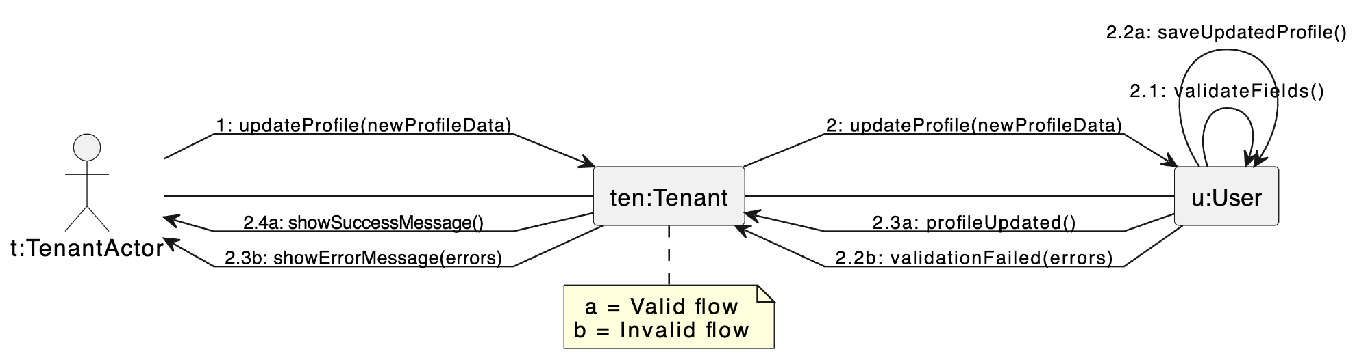

FR02 - Search properties (Done by:Anisa Domi)

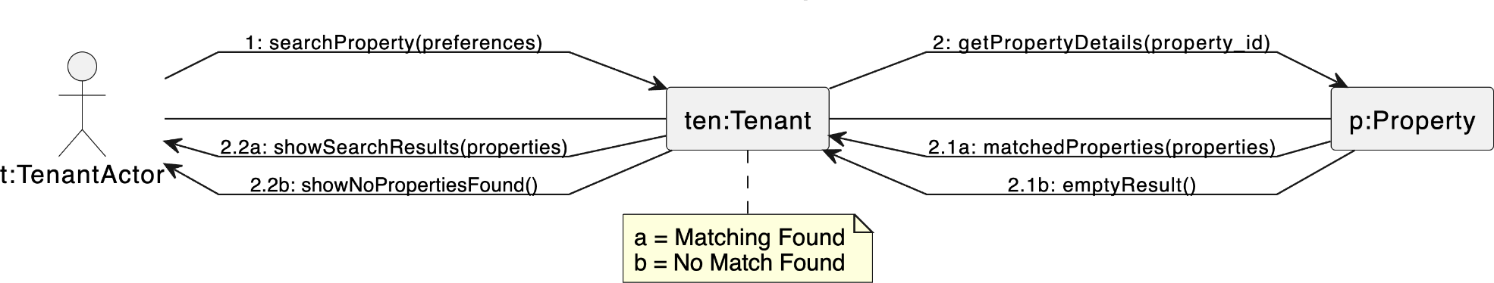

FR03 - Filter properties (Done by:Anisa Domi)

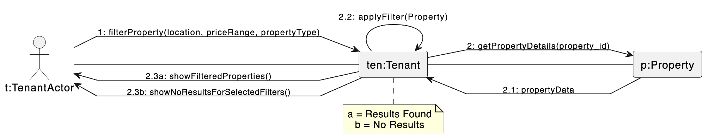

FR04 - View property details and booking history (Done by:Anisa Domi)
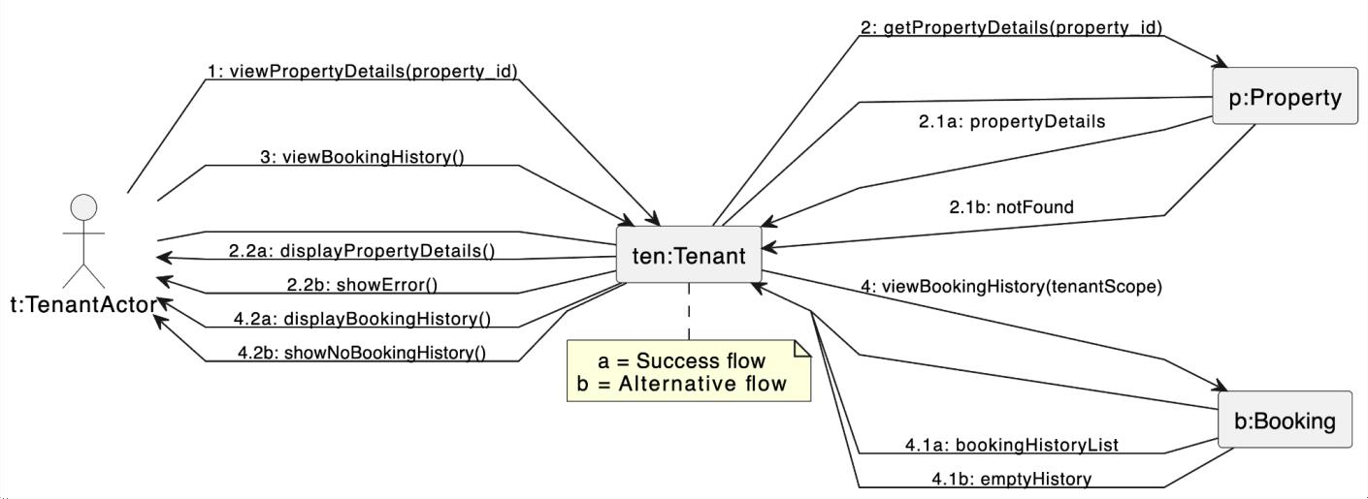

FR05 - Send rental requests and message to property owners (Done by:Anisa Domi)

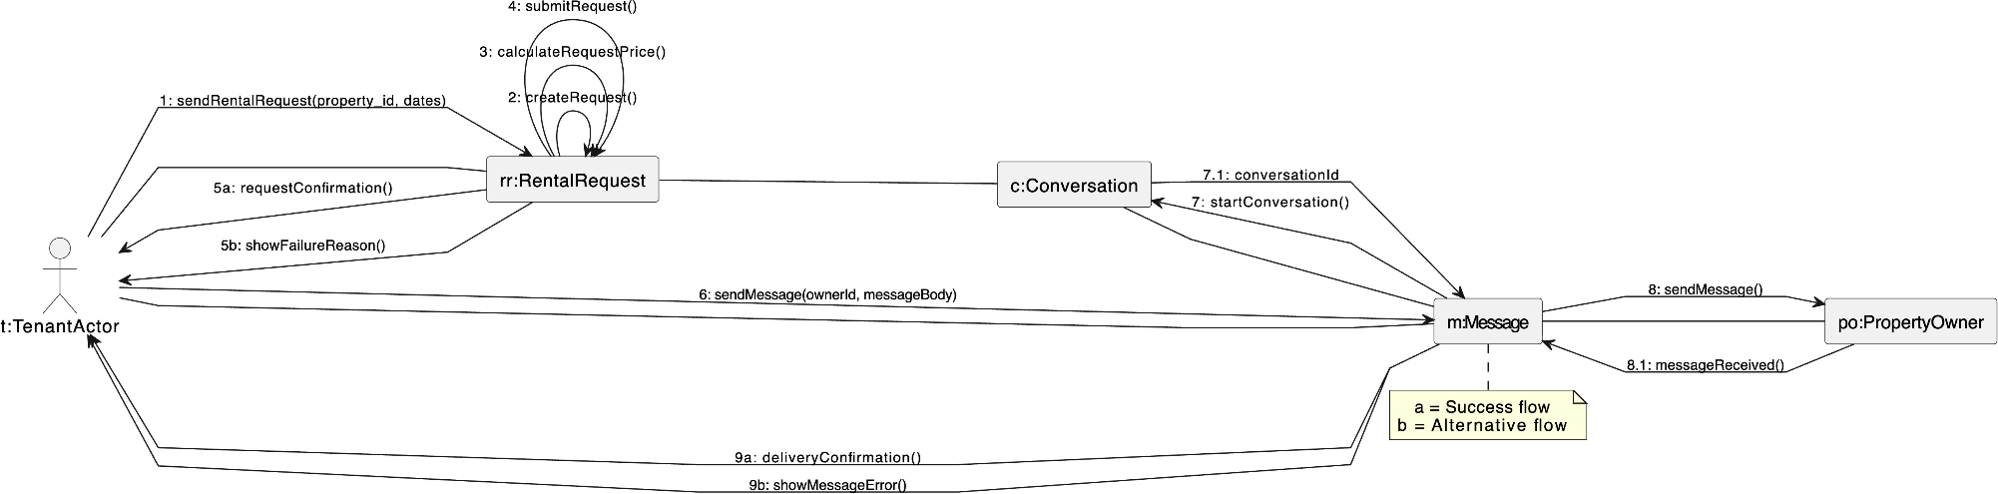

FR06 - Cancel rental request (Done by:Anisa Domi)

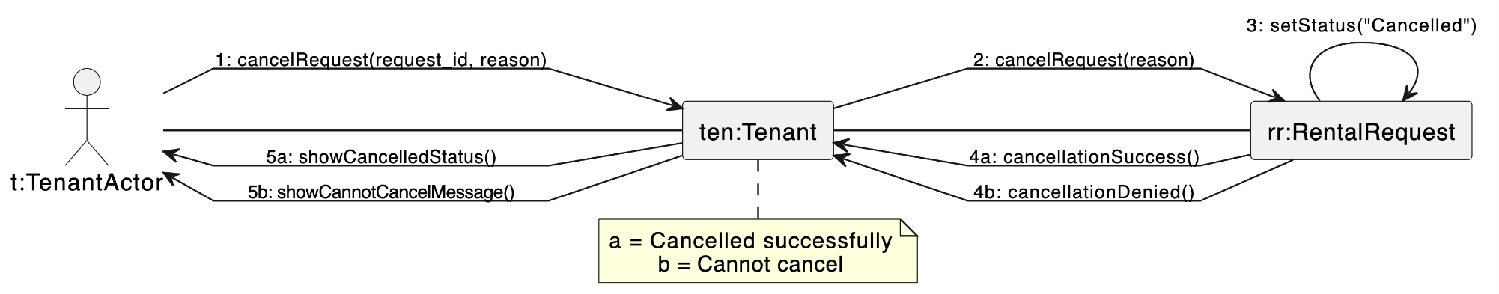

FR7-Receive Messages from property owners (Done by: Haidi Toto)
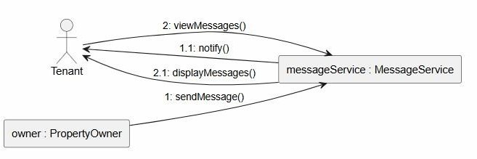
FR8 – Submit Rental Payment (Done by: Haidi Toto)
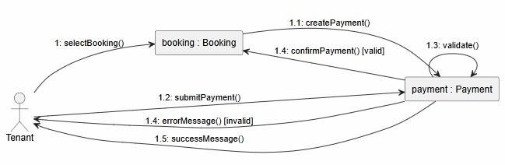
FR9 – Save Favourite Properties for later viewing (Done by: Haidi Toto)
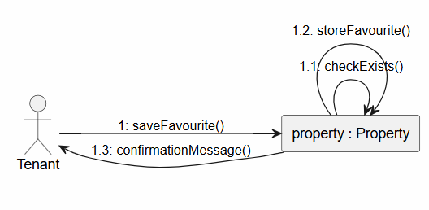
FR10 – Review and Rate Property (Done by: Haidi Toto)
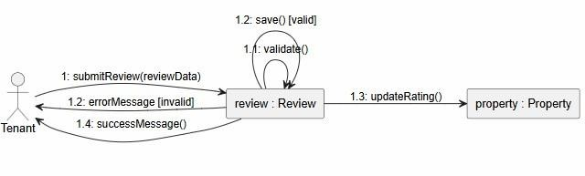

FR11 – Update Profile information and Availability of Rental (Done by: Haidi Toto)
Propertie
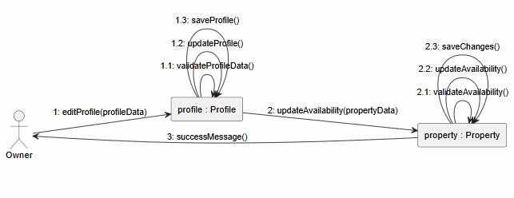
FR12 – Add Property Listing (Done by: Haidi Toto)
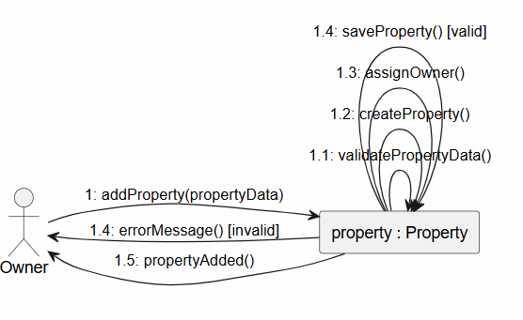
FR13-Upload Property Images (Done by: Ledio Tafciu)
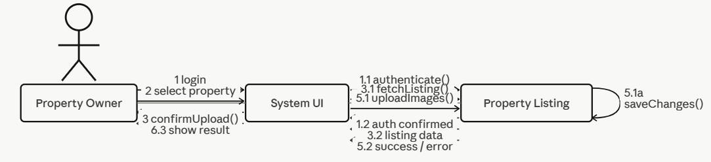

FR14 - Edit Property Listing (Done by: Ledio Tafciu)
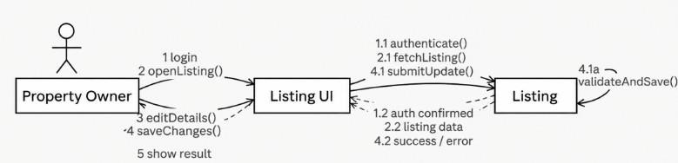
FR15 - Delete Property Listing (Done by: Ledio Tafciu)
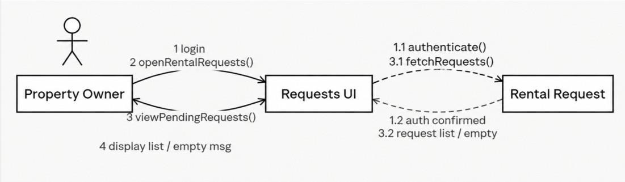
FR16 - View Rental Requests (Done by: Ledio Tafciu)
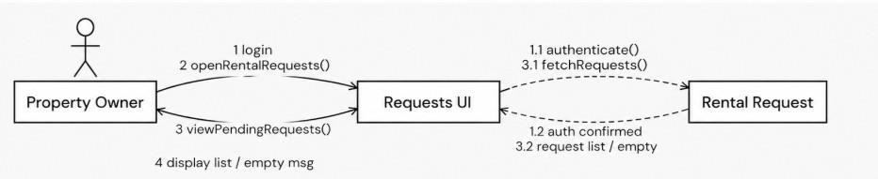

FR17 - Accept or Reject Rental Request (Done by: Ledio Tafciu)
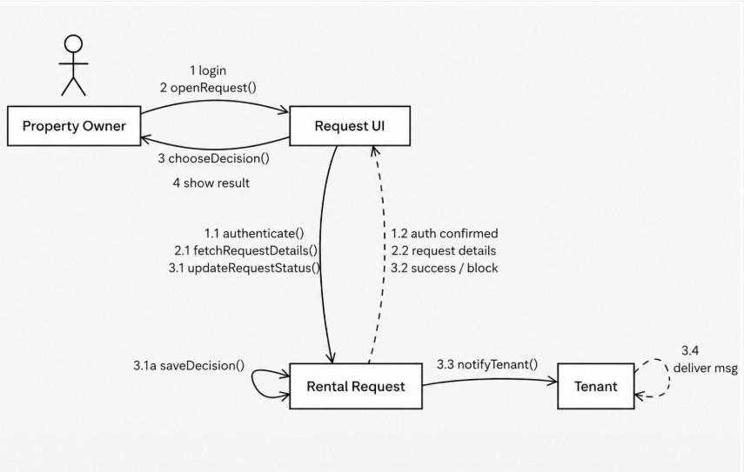
FR18 - Send Message To Tenant (Done by: Ledio Tafciu)
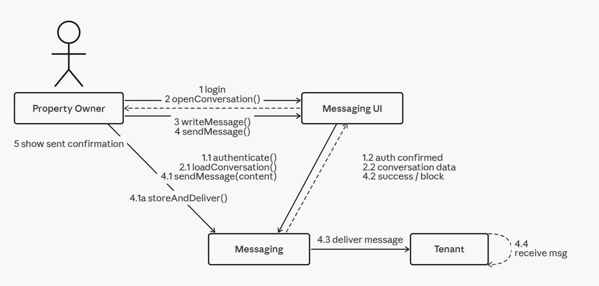

FR19 - View Booking History (Done by:Desard Lybeshari)
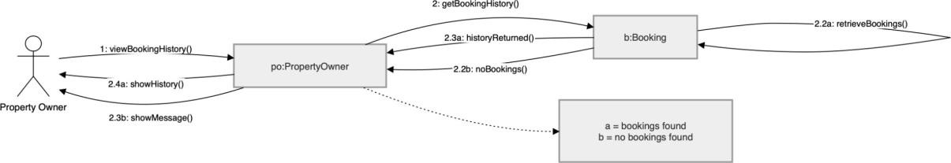

FR20 - Mark Property as Unavailable or Rented (Done by:Desard Lybeshari)

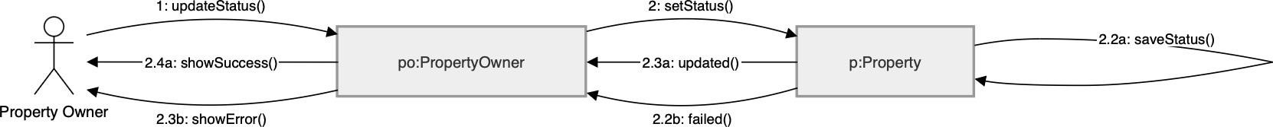

FR21 - Edit User Accounts (Done by:Desard Lybeshari)
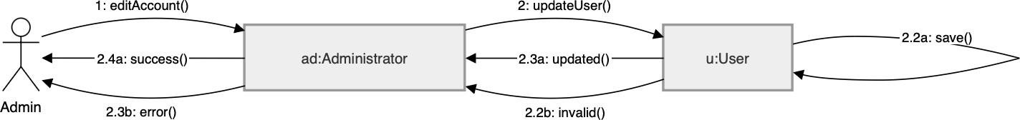

FR22 - Delete User Accounts (Done by:Desard Lybeshari)
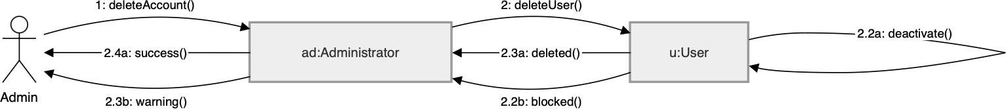

FR23 - Monitor Rental Transactions (Done by:Desard Lybeshari)

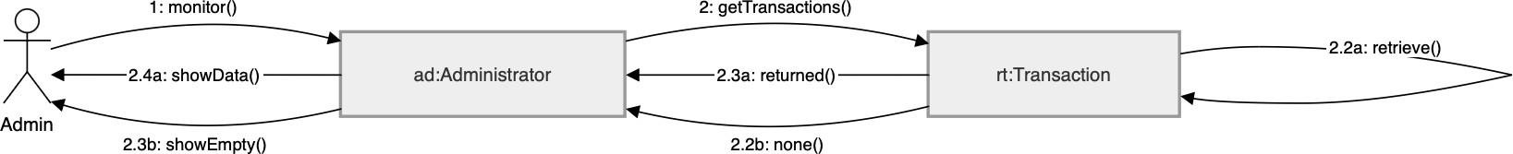

FR24 - View System Reports and Property Listings (Done by:Desard Lybeshari)

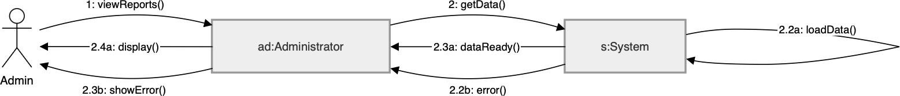

FR25- Remove inappropriate listings (Done by:Matias Bali)

FR26- Manage disputes & system settings (Done by:Matias Bali)

FR27- Restore user accounts (Done by:Matias Bali)
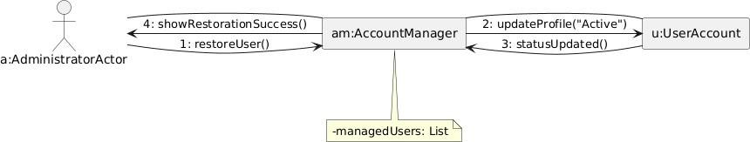

FR28- Suspend user accounts (Done by:Matias Bali)

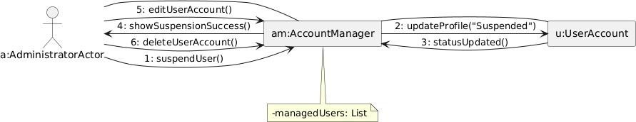

FR29- Verify and Approve property listings (Done by:Matias Bali)
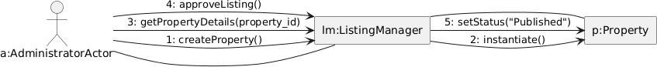

FR30- Monitor rental requests (Done by:Matias Bali)

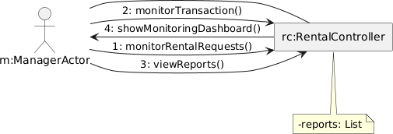
FR31 – Generate Management Reports (Done by: Ornelt Lemellari)
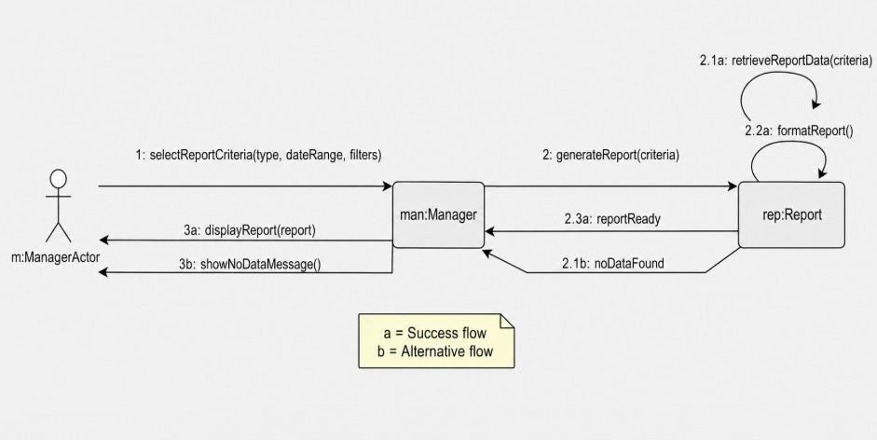

FR32 – Approve Large Discounts (Done by: Ornelt Lemellari)
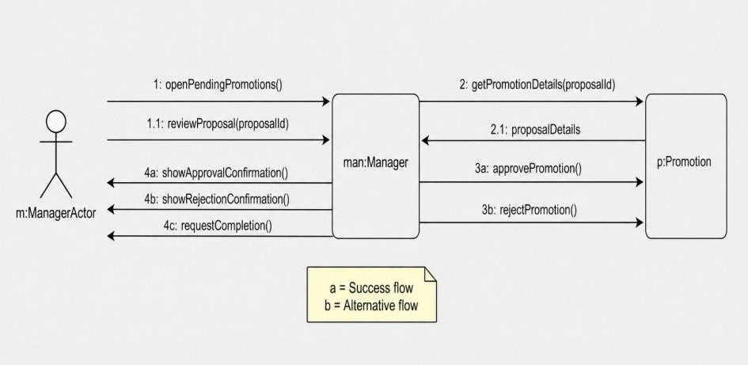

FR33 – Review Complaints and forward unresolved issues (Done by: Ornelt Lemellari)
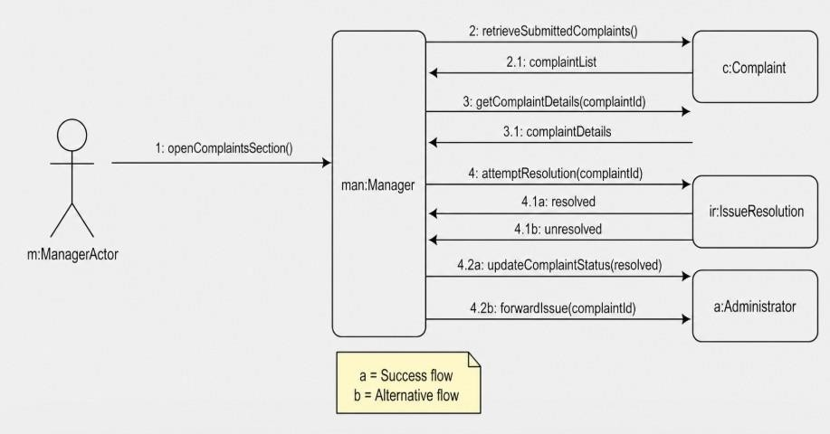

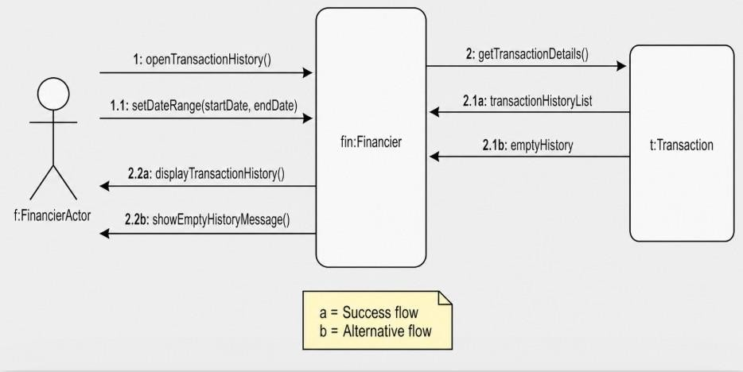
FR34 – View Transaction History (Done by: Ornelt Lemellari)

FR35 – Monitor Payment process and Security (Done by: Ornelt Lemellari)
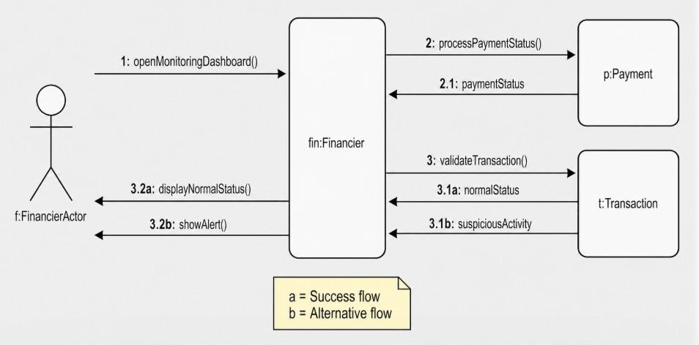

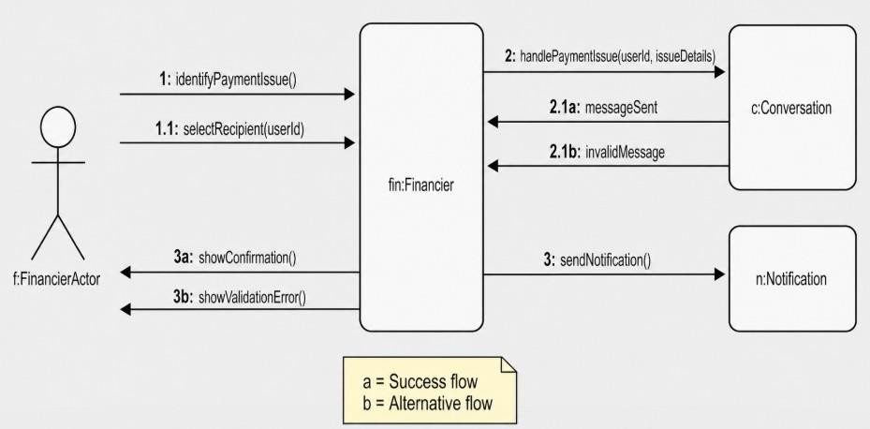
FR36 – Communicate Payment Issues with tenants and owners (Done by: Ornelt Lemellari)

FR37- Approve refunds for cancelled rental transactions (Done by:Kevin Muho)
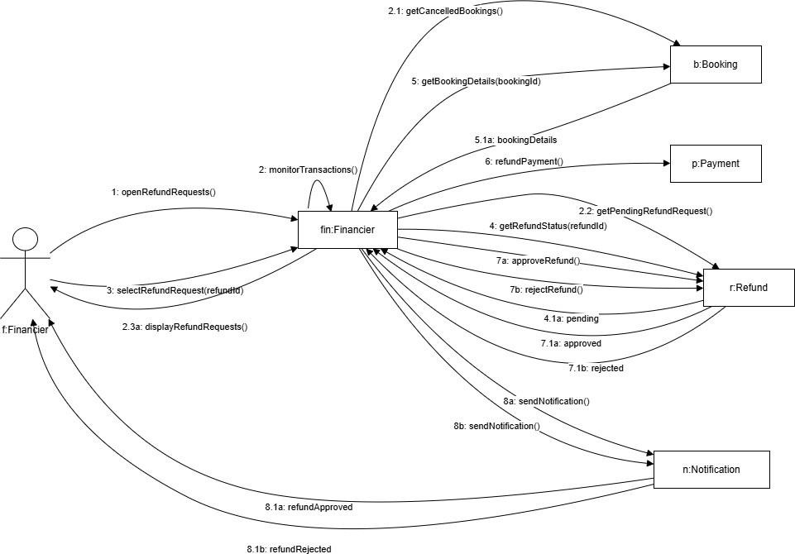

FR38- Manage Complaints (Done by: Kevin Muho)

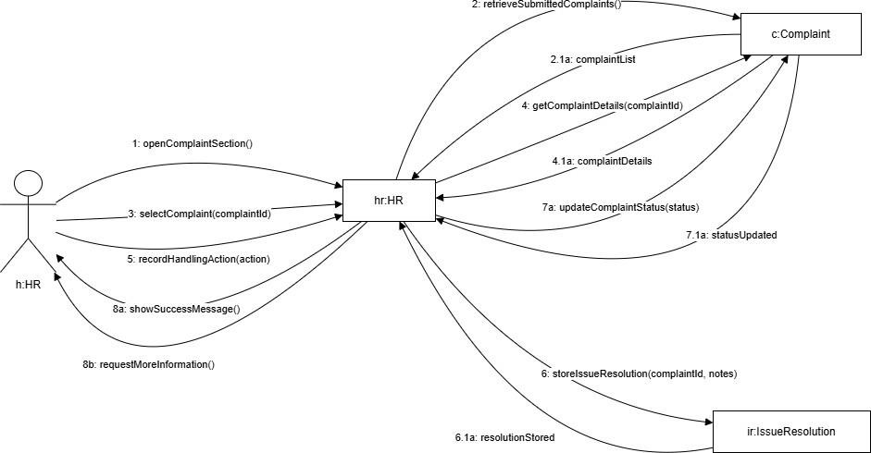

FR39- Send notifications and reminders (Done by:Kevin Muho)
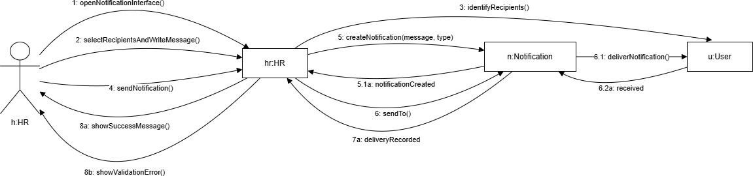

FR40- Maintain Record of User Issues and Resolutions (Done by:Kevin Muho)

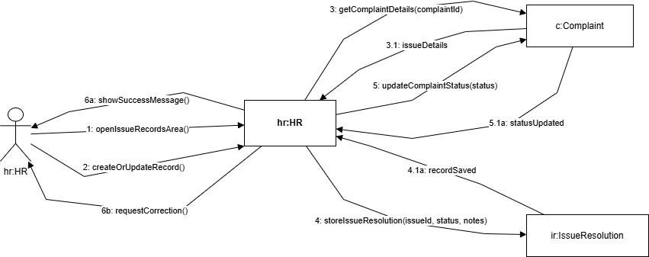

FR41- Register Account (Done by:Kevin Muho)

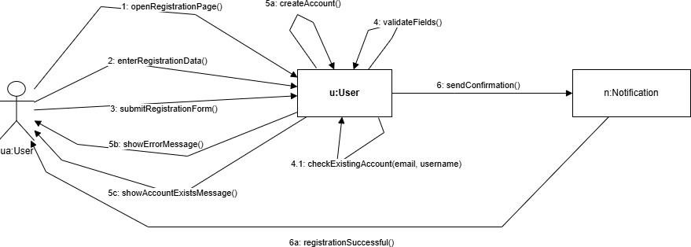

FR42 - Log In (Done by:Kevin Muho)
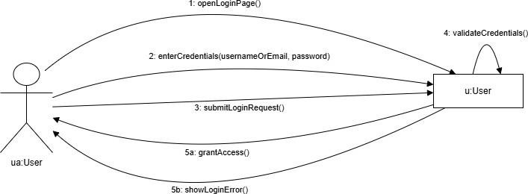

FR43 – Log Out (Done by:Kevin Muho)
